JAVA ASSIGNMENT-6 (14/11/2018)

1)Write a java program to find the avg of an array

class Avg
{
static void av()
{
int a[]={10,20,50,70};
float sum=0;
float avg;
for(int i=0;i<a.length;i++)
{
sum=sum+a[i];
}
System.out.println("sum is "+sum);
System.out.println("avg is "+(sum/a.length));
}
}
class TestAvg
{
public static void main(String args[])
{
Avg.av();
}
}

Output:
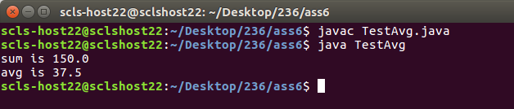

2)Write a java program to implement the arithmetic operations on consecutive elements of an array
class TestAR
{
public static void main(String args[])
{
int a[]={12,10,4,6,7};
for(int i=0;i<a.length-1;i++)
{
int m=a[i]+a[i+1];
System.out.println(" sum is "+m);
}
System.out.println("==================================");
for(int i=0;i<a.length-1;i++)
{
int n=a[i]-a[i+1];
System.out.println(" substraction is "+n);
}
System.out.println("==================================");
for(int i=0;i<a.length-1;i++)
{
int o=a[i]*a[i+1];
System.out.println(" multiplication is "+o);
}
System.out.println("==================================");
for(int i=0;i<a.length-1;i++)
{
float p=a[i]/a[i+1];
System.out.println(" division is "+p);
}
System.out.println("==================================");
for(int i=0;i<a.length-1;i++)
{
int q=a[i]%a[i+1];
System.out.println(" modulas is "+q);
}
System.out.println("==================================");

}
}

Output:
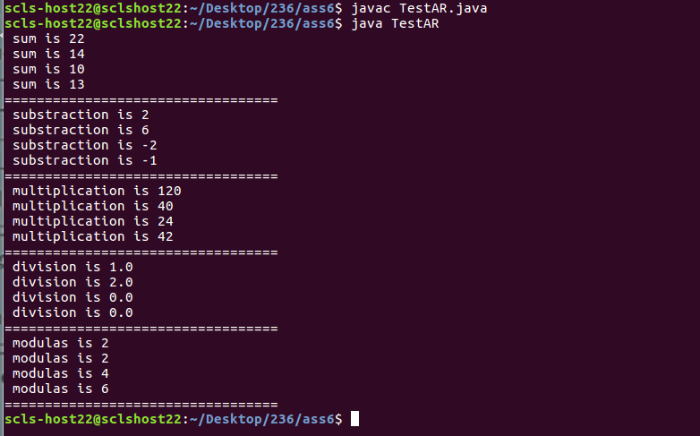

3)Write a java program to find the even and odd numbers in an array

class TestEOAr
{
public static void main(String args[])
{
int a[]={10,20,35,40,50};
for(int i=0;i<a.length;i++)
{
if(a[i]%2==0)
{
System.out.println(a[i]+" is even number");
}
else
{
System.out.println(a[i]+" is odd number");
}
}
}
}
Output:
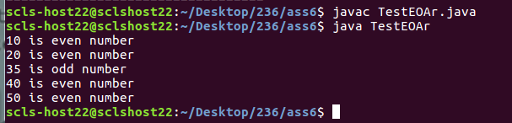

4)Write a java program to find the vowels and consonants in an array

class TestVowel
{
public static void main(String args[])
{
char a[]={'a','r','e','j'};
for(int i=0;i<a.length;i++)
{
if(a[i]=='a'||a[i]=='e'||a[i]=='i'||a[i]=='o'||a[i]=='u')
{
System.out.println(a[i]+" is vowel");
}
else
{
System.out.println(a[i]+" is consonant");
}
}
}
}
Output:
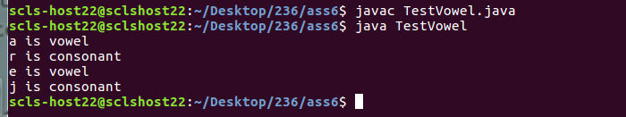

5)Write a java program to find the addition on array elements and perfom substraction on resulted array and then so on remaining arithmetic operations

class TestArOp
{
public static void main(String args[])
{
int a[]={12,24,344,44,53,10,30,20};
int b[]=new int[4];
int c[]=new int[2];
int d[]=new int[1];
for(int i=0,j=0;i<a.length-1;i=i+2,j++)
{
b[j]=a[i]+a[i+1];
System.out.println("sum is "+b[j]);
}
for(int j=0,k=0;j<b.length-1;j=j+2,k++)
{
c[k]=b[j]-b[j+1];
System.out.println("substraction is "+c[k]);
}
for(int k=0;k<c.length-1;k++)
{
d[0]=c[k]*c[k+1];
System.out.println("multiplication is "+d[0]);
}
float f=(float)(d[0]/a.length);
System.out.println("division is "+f);
}
}
Output:

